Appendix : IX

MANDATORY PUBLIC DISCLOSURE

**A. GENERAL INFORMATION**

|  |  |  |
| --- | --- | --- |
| **S.NO.** | **INFORMATION** | **DETAILS** |
| 1 | NAME OF SCHOOL | DAV PUBLIC SCHOOL |
| 2 | AFFILIATION NO. | 3330014 |
| 3 | SCHOOL CODE | 15054 |
| 4 | COMPLETE ADDRESS WITH PIN | SECL, VASANT VIHAR, BILASPUR(C.G.) PIN: 495006 |
| 5 | PRINCIPAL NAME & QUALIFICATION | MR. K. PARTHIPAN , M.A. , B.Ed. |
| 6 | SCHOOL EMAIL ID | davps.bsp@mail.com |
| 7 | CONTACT DETAILS (LANDLINE/MOB.) | LAND LINE : 07752291072  MOB. : 6232511700 |

**B. DOCUMENTS AND INFORMATION :**

|  |  |  |
| --- | --- | --- |
| S.NO. | DOCUMENTS / INFORMATION | LINKS OF UPLOADED DOCUMENTS ON YOUR SCHOOL’S WEBSITE |
| 1 | COPIES OF AFFILIATION / UPGRADATION LETTER AND RECENT EXTENSION OF AFFILIATION | http://davbsp.org/File/6707/4XP_AFFILIATION_compressed.pdf |
| 2 | COPIES OF SOCIETIES / TRUST / COMPANY REGISTRATION / RENWAL CERTIFICATE, AS APPICABLE | http://davbsp.org/File/6707/FWC_DAV%20TRUST%20SOCIETY.pdf |
| 3 | COPIES OF RECONGNITION CERTIFICATE UNDER RTE ACT, 2009 AND IT’S RENEWAL IF APPLICABLE | http://davbsp.org/File/6707/J2G_RTE_compressed.pdf |
| 4 | COPY OF VALID BUILDING SAFETY CERTIFICATE AS PER THE NATIONAL BUILDING CODE | http://davbsp.org/File/6707/RVU_DOC%20AND%20INFO.pdf |
| 5 | COPY OF VALID FIRE SAFETY CERTIFICATE ISSUED BY THE COMPETENT AUTHORITY | http://davbsp.org/File/6707/RVU_DOC%20AND%20INFO.pdf |
| 6 | COPIES OF VALID MEDICAL HEALTH ,WATER AND SANITATION CERTIFICATES | http://davbsp.org/File/6707/RVU_DOC%20AND%20INFO.pdf |

**C. RESULT AND ACADEMICS**

|  |  |  |
| --- | --- | --- |
| S.NO. | DOCUMENTS / INFORMATION | UPLOAD DOCUMENTS |
| 1 | FEE STRUCTURE OF THE SCHOOL | http://davbsp.org/File/6707/G4N_Fee%20STRUCTURE.pdf |
| 2 | ANNUAL ACADEMIC CALANDER | http://davbsp.org/File/6707/TR9_ACADEMIC%20CALANDER.pdf |
| 3 | LIST OF SCHOOL MANAGEMENT COMMITTEE | http://davbsp.org/File/6707/GM6_LMC%20Members_2.pdf |
| 4 | LAST THREE YEAR RESULT OF THE BOARD EXAMINATION | http://davbsp.org/File/6707/HWQ_X%20and%20XII%20RESULT%20LAST%204%20YEARS.docx |

**D. STAFF (TEACHING )**

|  |  |  |
| --- | --- | --- |
| S.NO. | DOCUMENTS / INFORMATION | UPLOAD DOCUMENTS |
| 1. | LIST OF TEACHING STAFF WITH THEIR QUALIFICATION | http://davbsp.org/File/6707/HVC_STAFF%20DETAILS.pdf |

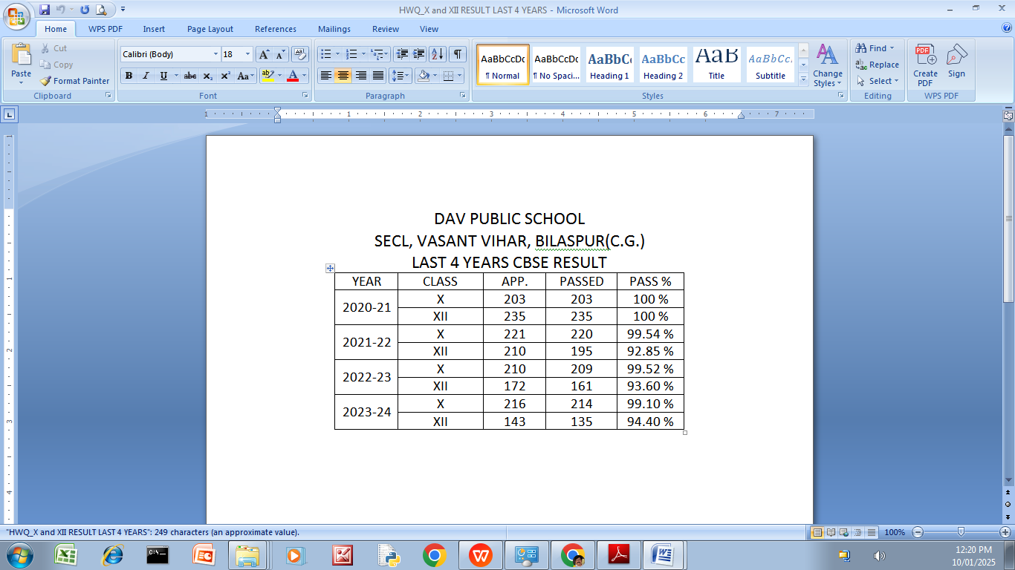

**E. SCHOOL INFRASTRUCTURE:**

|  |  |  |
| --- | --- | --- |
| S.NO. | INFORMATION | DETAILS |
| 1 | TOTAL CAMPUS AREA OF THE SCHOOL (IN SQ. MTR.) | 28329 |
| 2 | NO. AND SIZE OF THE CLASS ROOMS (IN SQ. MTR.) | 64 & 58 |
| 3 | NO. AND SIZE OF LABORATORIES INCLUDING COMPUTER LABS(IN SQ. MTR) | 11 & 256 |
| 4 | INTERNET FACILITY (Y/N) | YES |
| 5 | NO. OF GIRLS TOILETS | 13 |
| 6 | NO. OF BOYS TOILETS | 13 |
| 7 | LINK OF YOUTURE VIDEO OF THE INSPECTION OF SCHOOL COVERING THE INFRASTRUCTURE OF THE SCHOOL | https://youtu.be/L07h8H84RIs |