Appendix : IX
MANDATORY PUBLIC DISCLOSURE
A. GENERAL INFORMATION
S.NO. | INFORMATION | DETAILS
1 | NAME OF SCHOOL | DAV PUBLIC SCHOOL
2 | AFFILIATION NO. | 3330014
3 | SCHOOL CODE | 15054
4 | COMPLETE ADDRESS WITH PIN | SECL, VASANT VIHAR, BILASPUR(C.G.) PIN: 495006
5 | PRINCIPAL NAME & QUALIFICATION | MR. K. PARTHIPAN , M.A. , B.Ed.
6 | SCHOOL EMAIL ID | davps.bsp@mail.com
7 | CONTACT DETAILS (LANDLINE/MOB.) | LAND LINE : 07752291072  MOB. : 6232511700

B. DOCUMENTS AND INFORMATION :
S.NO. | DOCUMENTS / INFORMATION | LINKS OF UPLOADED DOCUMENTS ON YOUR SCHOOL’S WEBSITE
1 | COPIES OF AFFILIATION / UPGRADATION LETTER AND RECENT EXTENSION OF AFFILIATION | http://davbsp.org/File/6707/4XP_AFFILIATION_compressed.pdf
2 | COPIES OF SOCIETIES / TRUST / COMPANY REGISTRATION / RENWAL CERTIFICATE, AS APPICABLE | http://davbsp.org/File/6707/FWC_DAV%20TRUST%20SOCIETY.pdf
3 | COPIES OF RECONGNITION CERTIFICATE UNDER RTE ACT, 2009 AND IT’S RENEWAL IF APPLICABLE | http://davbsp.org/File/6707/E7M_RTE%20Recognition%20July%202024%20to%20July%202027_compressed.pdf
4 | COPY OF VALID BUILDING SAFETY CERTIFICATE AS PER THE NATIONAL BUILDING CODE | http://davbsp.org/File/6707/CKR_Building%20Certificate.pdf
5 | COPY OF VALID FIRE SAFETY CERTIFICATE ISSUED BY THE COMPETENT AUTHORITY
6 | COPIES OF VALID MEDICAL HEALTH ,WATER AND SANITATION CERTIFICATES | http://davbsp.org/File/6707/P99_Drinking%20Water%20AND%20MEDICAL%20CERTIFICATE.pdf
7 | DOCUMENTS & INFORMATIONS | http://davbsp.org/File/6707/2HJ_DOCUMENTS_INFORMATION.pdf

C. RESULT AND ACADEMICS
S.NO. | DOCUMENTS / INFORMATION | UPLOAD DOCUMENTS
1 | FEE STRUCTURE OF THE SCHOOL | http://davbsp.org/File/6707/JR3_Fee%20structure%202026-27.pdf
2 | ANNUAL ACADEMIC CALANDER
3 | LIST OF SCHOOL MANAGEMENT COMMITTEE | http://davbsp.org/File/6707/JPQ_LMC%20List-2026-2027.pdf
4 | LAST THREE YEAR RESULT OF THE BOARD EXAMINATION | http://davbsp.org/File/6707/AMP_X%20AND%20XII%20RESULT%20NEW.docx
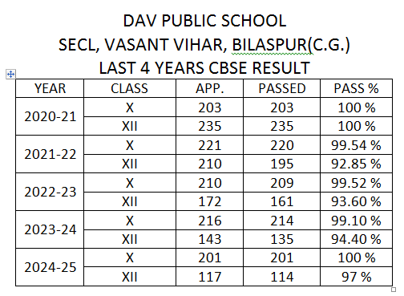
D. STAFF (TEACHING )
S.NO. | DOCUMENTS / INFORMATION | UPLOAD DOCUMENTS
1. | LIST OF TEACHING STAFF WITH THEIR QUALIFICATION | http://davbsp.org/File/6707/QN2_Teaching%20Staff%20details.pdf

E. SCHOOL INFRASTRUCTURE:
S.NO. | INFORMATION | DETAILS
1 | TOTAL CAMPUS AREA OF THE SCHOOL (IN SQ. MTR.) | 28329
2 | NO. AND SIZE OF THE CLASS ROOMS (IN SQ. MTR.) | 64 & 58
3 | NO. AND SIZE OF LABORATORIES INCLUDING COMPUTER LABS(IN SQ. MTR) | 11 & 256
4 | INTERNET FACILITY (Y/N) | YES
5 | NO. OF GIRLS TOILETS | 13
6 | NO. OF BOYS TOILETS | 13
7 | LINK OF YOUTURE BIDEO OF THE INSPECTION OF SCHOOL COVERING THE INFRASTRUCTURE OF THE SCHOOL | https://youtu.be/L07h8H84RIs

