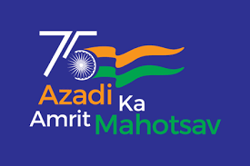 |  | 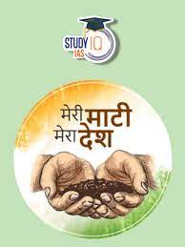

On the occasion of “Azadi Ka Amrit Mahotsav” celebration our school has taken “PANCH PRAN PLEDGE”.
Dr. Pravin Kumar Mishra , DEAN & HOD of History Dept. GGU,Bilaspur(C.G.) has delivered a speech. Our Hon’ble LMC , Chairman Shri. Ratnesh Kumar Shrivastava (G.M. W/CSR – SECL)has also attended the celebration along with Shri. Chandra Kumar Pathak (CSR Manager-SECL).
HIGHLIGHTS OF THE SPECIAL GUEST’S ADDRESS
- Doctored accounts in the history books to unglorify Our mighty ancestors & forefathers.
- India was richly equipped with the knowledge of Science & Technology way ahead than other so called developed nations.
- Gradually, the genuine & authentic information will be incorporated in books – an initiative by the Govt. of India and its agent- NCERT
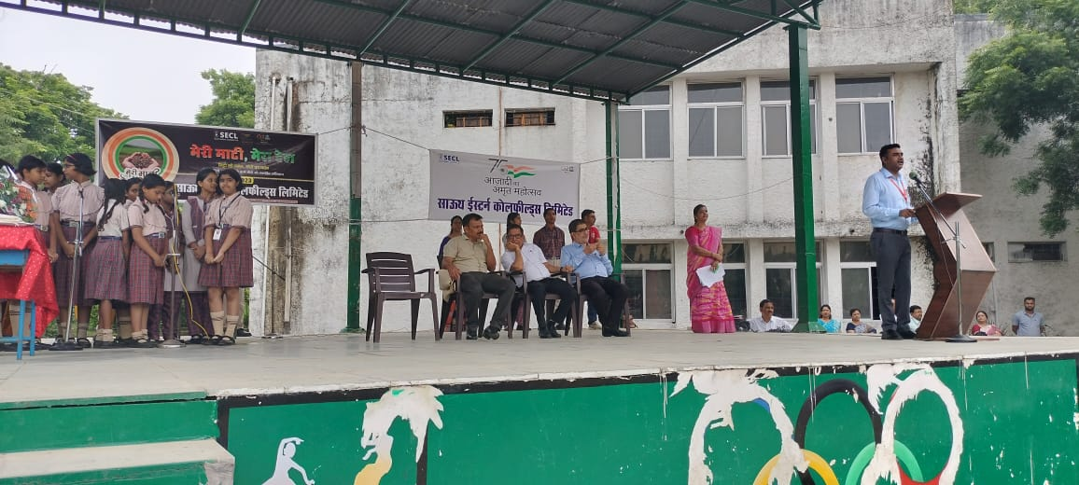 | 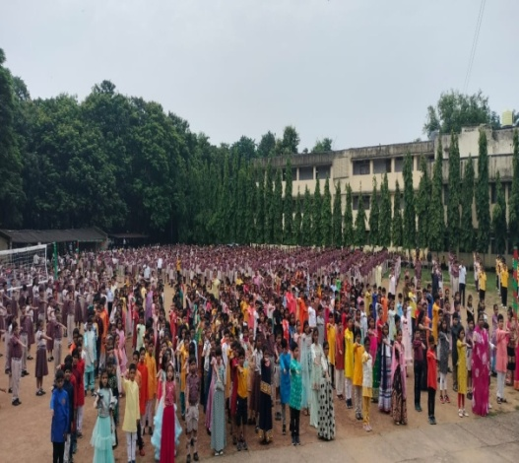 | 